Introduction from the Chair
Coming up in this newsletter!
- Introduction from the Northumberland Fire Group Chair
- Case Study of the Simonside Wildfire April 2020
- Current Priorities for the Northumberland Fire Group
- Latest Wildfire News from across the UK
- What is the Northumberland Fire Group?

“Welcome to the Summer 2020 newsletter from the Northumberland Fire Group (NFG). In this edition, we had hoped to bring you news of further collaborative burning projects, training courses and wildfire exercises that had been completed so far this year, or planned for the autumn. Of course, like everybody else, the NFG has been greatly affected by COVID and some of our plans have been put on hold.

However, wildfire is one thing that has not been put on hold by COVID! The weather earlier this year, coupled with irresponsible behaviour from some members of the public during the post lockdown period has meant that the NFG members have had a busy year out on the ground liaising with the public and fighting fires. Fortunately, none of the wildfires in the county this year have presented a risk to life or property, but all of them have caused environmental damage which will take time and money to restore. The fact that these fires were not more serious is largely down to the skills of Northumberland Fire & Rescue Service (NFRS) coupled with local moorland managers, the partnership working and expertise of NFG members and the support and local knowledge of the land managers in the affected areas.

We have found yet again that the planning and preparedness work by NFRS and the NFG is crucial to helping ensure that wildfires are quickly controlled and extinguished to prevent further risk and damage. The Northumberland Wildfire Fire Plan project continues to go from strength to strength and continues to be an example of best practice that is being replicated in other areas of the UK. By gathering key information about sites that are at higher risk before wildfires happen, we are ensuring that responding fire crews are well prepared if a wildfire breaks out and this helps ensure a better outcome.

We are not complacent. After each major incident, an evaluation takes place to see what lessons could be learnt and how the response could be improved in the future. In an era of seemingly ever increasing extreme weather events we must not drop our guard or else the landscapes and eco-systems that we love could suffer, along with the people who rely upon them for their living.”

Angus Collingwood Cameron
Chair of the Northumberland Fire Group

During the Spring of 2020 we experienced both a Government mandated lockdown of society and a significant period for wildfire incidents, both in Northumberland and around the UK. The long warm and dry period experienced during March, April and May provided perfect conditions for wildfires to develop and spread.
Wildfire Incidents in Northumberland during 2020
Many people will have noticed the news coverage of the large wildfires at Wareham Forest in Dorset and at Hatfield Moors in South Yorkshire. We have also been busy with wildfires in Northumberland. The Temporary Extreme Fire Risk Notice signs were put out for an extended period across the Northumberland countryside by Northumberland Fire Group members to warn members of the public about the severe fire risk. This helped to raise awareness of the risk, but despite this Northumberland FRS attended 5 wildfires during this period that met the Fire and Rescue Service definition of a wildfire.
The wildfires recorded so far have occurred across the County, from the Cheviot Hills and the Simonside Hills in the North, to the Hadrian’s Wall area in the South and West. Most of these fires burned for multiple days and some burned for over a week. All of the incidents were multiagency in nature, involving numerous fire crews and specialist officers from Northumberland Fire and Rescue Service as well as colleagues from Northumberland National Park Mountain Rescue Team and the assistance of several of the large estates and landowners. Repitition
While wildfire risk has reduced significantly during July 2020 due to cooler, wetter weather, the Northumberland Fire Group remains vigilant and will continue to share key messages with members of the public to help prevent wildfires from occurring. Please stay vigilant and follow HM Government’s latest guidance on the Countryside Code and how to access green spaces and the outdoors safely.

A Case Study of the Simonside Wildfire – INSERT ARTICLE FROM MOUNTAIN RESCUE

Current Priorities for the Northumberland Fire Group
The Northumberland Fire Group is currently delivering a number of key activities, which include:
- Identifying and sharing key lessons learned during the 2020 wildfires and further improving the group’s approach to wildfires in future;
- Supporting Northumberland FRS to deliver the Wildfire Fire Plan Project, through the identification of new sites requiring wildfire fire plans and the regular review and updates to existing plans;
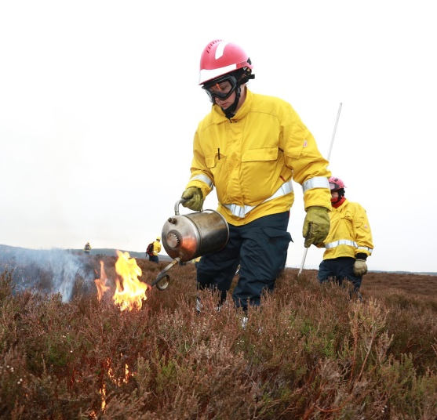
- Creating a new wildfire hub station at Haltwhistle Fire Station during 2020. This will involve the purchase of additional wildfire equipment and the delivery of additional wildfire training to firefighters and officers on the station using NFG funds.
- Delivering the Northumberland Collaborative Burning Project – a partnership project aimed at managing and reducing wildfire risk across Northumberland through collaboration and partnership working.
- Continually monitoring the wildfire risk across the County and raising public awareness when the risk becomes severe or extreme.
- Re-scheduling a farmer training event that was supposed to take place this spring
Latest Wildfire News from across the UK

Natural England publishes Wildfire Evidence Review

On 27th July 2020, Natural England published a report entitled “The causes and prevention of wildfire on heathlands and peatlands in England (NEER014)”. The scope of this review is restricted to the occurrence, causes, prevention and management of wildfires on open, semi-natural habitats in the UK with a particular focus upon heathlands and peatlands in England.

Members of the Northumberland Fire Group and England and Wales Wildfire Forum provided evidence that was considered during this review. Please click here to download a copy of the final report and the appendices.

Wildfire Webinar hosted by European Emergency Number Association (EENA)
Members of the NFG watched an interesting webinar on 23rd June 2020 which was hosted by EENA. The webinar, titled “Lessons Learned from the Australia Wildfires”, focused on the key lessons learned from the large wildfires in Australia that occurred during early 2020. The speakers on the webinar were Steve Warrington, CEO of Country Fire Authority of the State of Victoria, Australia and Claire Kowalewski from DG ECHO at the European Commission.
Please click here to view the presentations and a recording of the webinar.

National Consultations on England Peat Strategy and England Tree Strategy
Defra has recently launched two public consultations on a National Peat Strategy for England and a National Tree Strategy for England. The preservation and conservation of peat, and the planting of significant numbers of trees across the country, will have significant implications for wildfire risk.
Please take a look at the consultation documents and make a contribution to help ensure that wildfire risk is considered and integrated within both of these important strategies.
- Stakeholder Engagement on England Peat Strategy
  - Deadline for responses: 4th August 2020
  - Consultation information available at: https://consult.defra.gov.uk/natural-environment-policy/b005767e/
  - Please contact Defra directly at EPS@defra.gov.uk for further information

- Public Consultation on England Tree Strategy
  - Deadline for responses: 11th September 2020
  - Consultation information available at: https://consult.defra.gov.uk/forestry/england-tree-strategy/
  - Please contact Defra directly at Tree.Strategy.Consultation@defra.gov.uk for further information
Latest HM Government Guidance on Access to the Outdoors during COVID-19
HM Government has published some updated guidance on how to access the outdoors safely during COVID-19. Please follow this guidance to keep you and others safe!
- Guidance on Accessing Green Spaces Safely during Coronavirus
- COVID-19 version of the Countryside Code
What is the Northumberland Fire Group and how can I make contact?

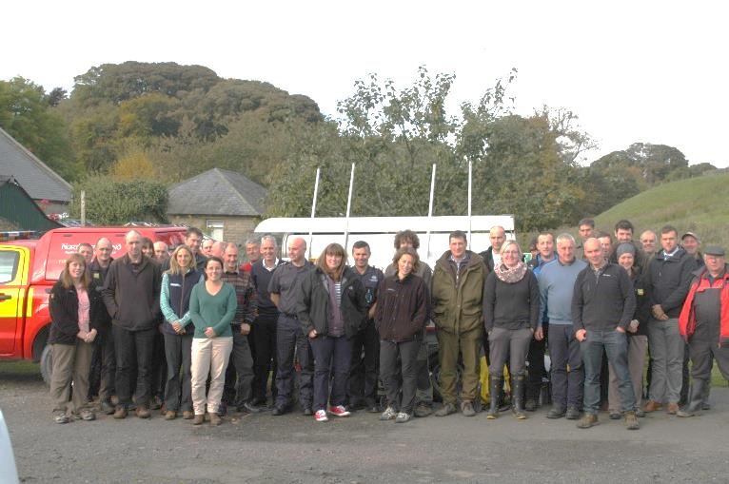
The Northumberland Fire Group (NFG) is a multiagency group of public and private sector partners that was established in 2008 (?) to address wildfire issues within Northumberland. The focus of the group is to improve wildfire prevention, wildfire preparedness and wildfire response across Northumberland through joint and collaborative working.
.
NFG Planning for Wildfire Event in Elsdon, 2016
Find out more!
If you would like to find out more about the work of the Northumberland Fire Group (NFG), or if you are interested in joining, please visit our web page at http://firegroup.northumberland.gov.uk
Please also feel free to contact the Secretary and the Chair:
- Robert Stacey, Secretary of the NFG and Wildfire Team Leader at Northumberland Fire and Rescue Service – robert.stacey@northumberland.gov.uk
- Angus Collingwood Cameron, Chair of the NFG and Northern Farmers and Landowners Group – aecc@nrpg.co.uk

The UK Fire and Rescue Services define a wildfire as “any unwanted vegetation that fulfils one or more of the following criteria: Involves a geographical area of at least 1 hectare; and/or has a sustained flame length of 1.5 metres or more; and/or requires a committed resource of at least 4 fire and rescue resources/vehicles; and/or requires resources to be committed for at least 6 hours; and/or presents a serious threat to life, property, infrastructure or the environment.” Source: UK FRS National Operational Guidance for Wildfires

